Afonso

Matheo

Activité HTML : Test de balise

Balise H1

<!DOCTYPE html>

<html>

<head>

    <meta charset='utf-8'>

    <title>TP1 2</title>

</head>

<body>

    <!-- test de balise ici -->

    <h1>Bienvenue</h1>

</body>

</html>

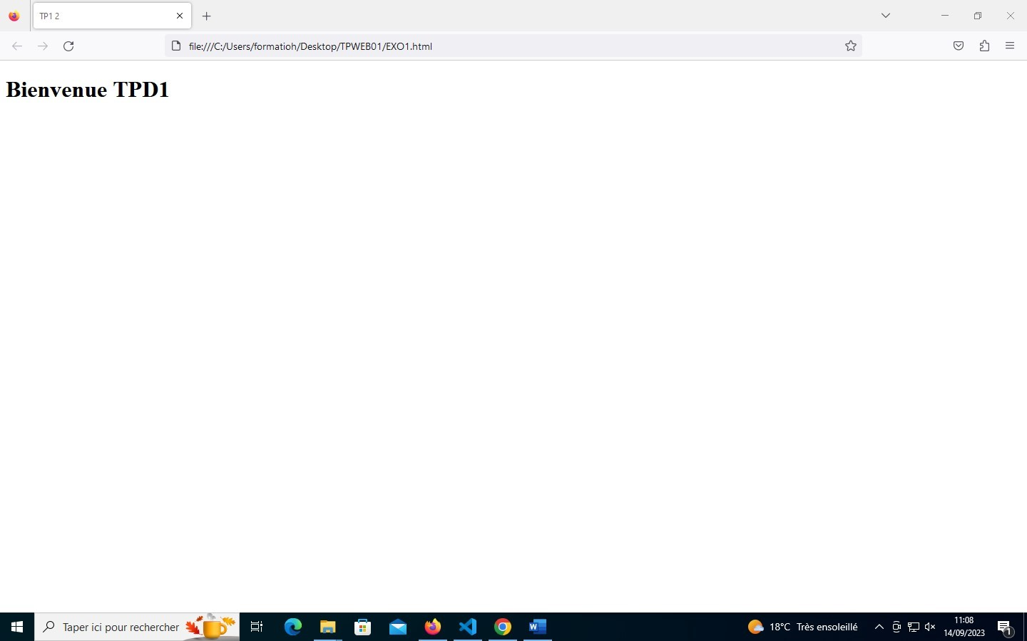

Balise script

<!DOCTYPE html>

<html>

<head>

    <title>Exemple JavaScript</title>

</head>

<body>

    <button id="afficherMessage">Cliquez ici</button>

    <p id="message"></p>

    <script>

        // Fonction pour afficher le message

        function afficherMessage() {

            document.getElementById("message").textContent = "Bonjour, monde !";

        }

        // Écouteur d'événement pour le bouton

        document.getElementById("afficherMessage").addEventListener("click", afficherMessage);

    </script>

</body>

</html>

# 

Balise image

<!DOCTYPE html>

<html>

<head>

    <meta charset='utf-8'>

    <title>TP1 2</title>

</head>

<body>

    <!-- test de balise ici -->

    <img src="image/channels4_profile.png" alt="" >

</body>

</html>

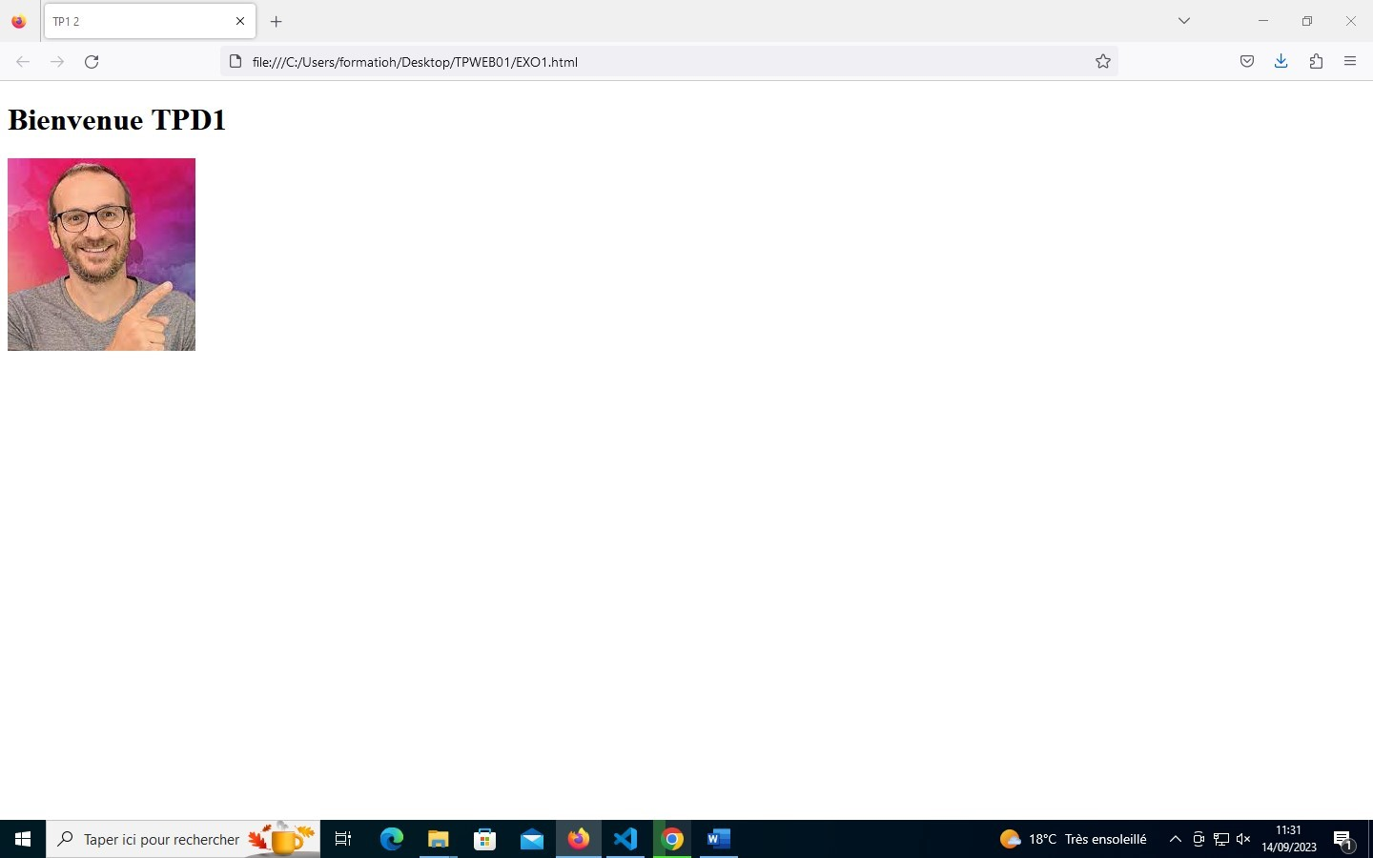

Balise a

<!DOCTYPE html>

<html>

<head>

    <meta charset='utf-8'>

    <title>TP1 2</title>

</head>

<body>

    <!-- test de balise ici -->

    <h1>Bienvenue TPD1</h1>

    <a href="URL_de _la_page_cible">lien pour un site</a>

</body>

</html>

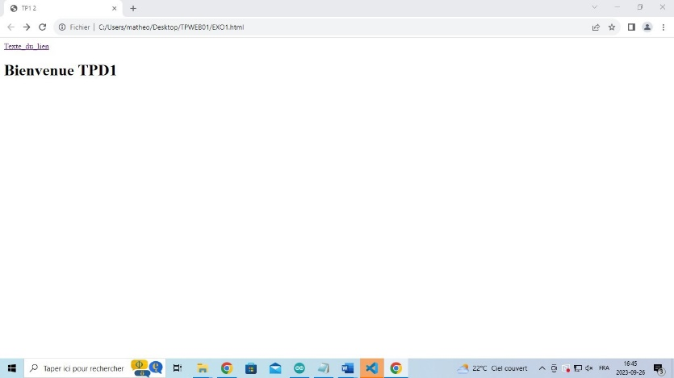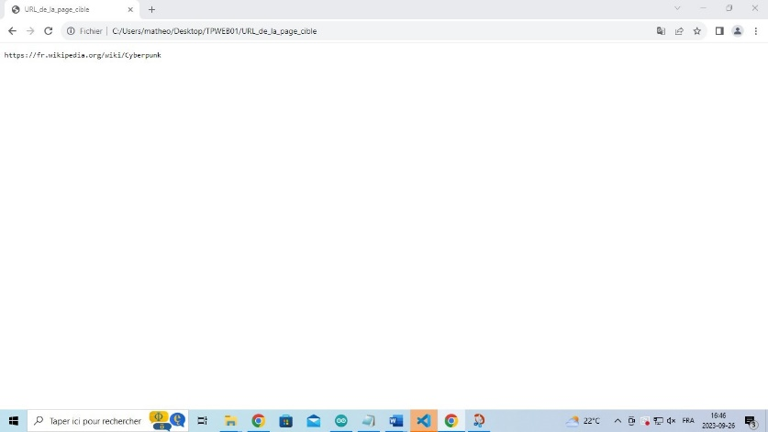

Balise table

<!DOCTYPE html>

<html>

<head>

    <meta charset='utf-8'>

    <title>TP1 2</title>

</head>

<body>

  <table>

      <tr>

        <th>En-tête 1</th>

        <th>En-tête 2</th>

      </tr>

      <tr>

        <td>Donnée 1</td>

        <td>Donnée 2</td>

      </tr>

  </table>

</body>

</html>

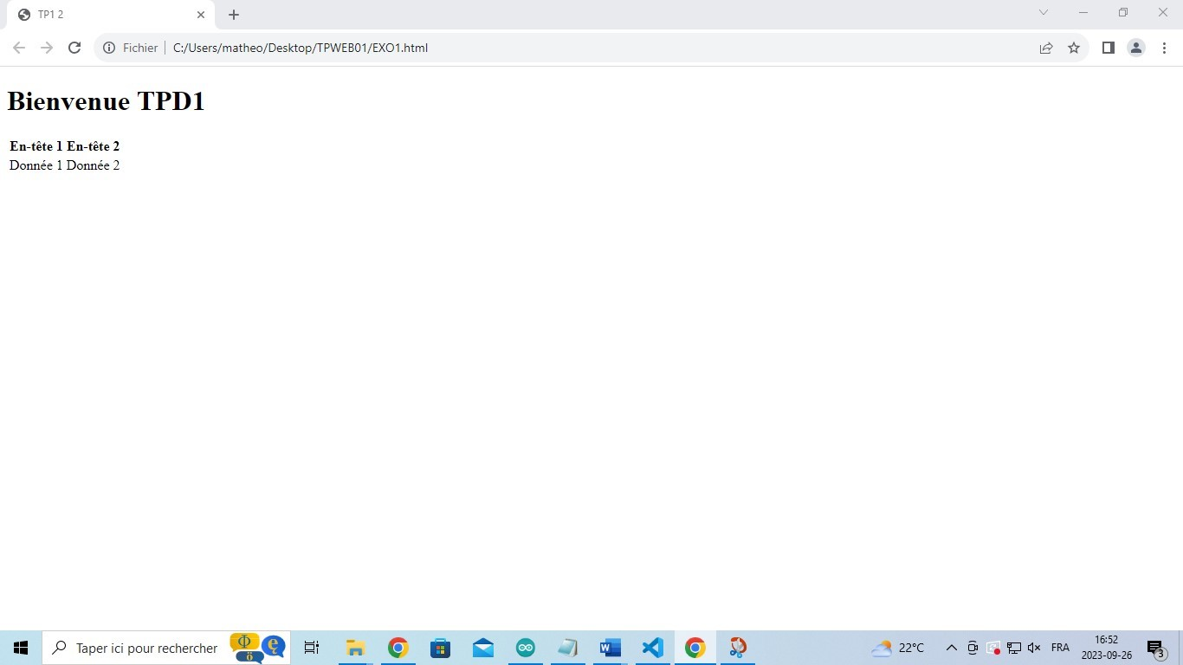

Balise strong

<!DOCTYPE html>

<html>

<head>

    <meta charset='utf-8'>

    <title>TP1 2</title>

</head>

<body>

    <strong>je suis matheo</strong>

</body>

</html>

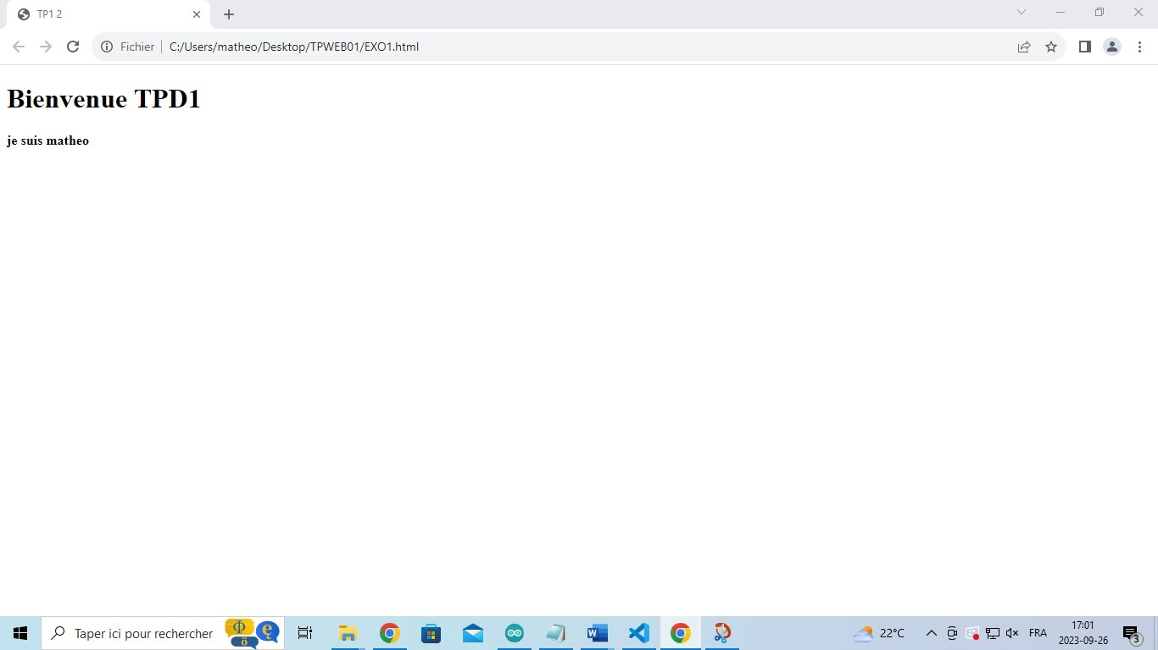

Balise ul

<!DOCTYPE html>

<html>

<head>

    <meta charset='utf-8'>

    <title>TP1 2</title>

</head>

<body>

    <ul>

      <li>matheo</li>

      <li>afonso</li>

    </ul>

</body>

</html>

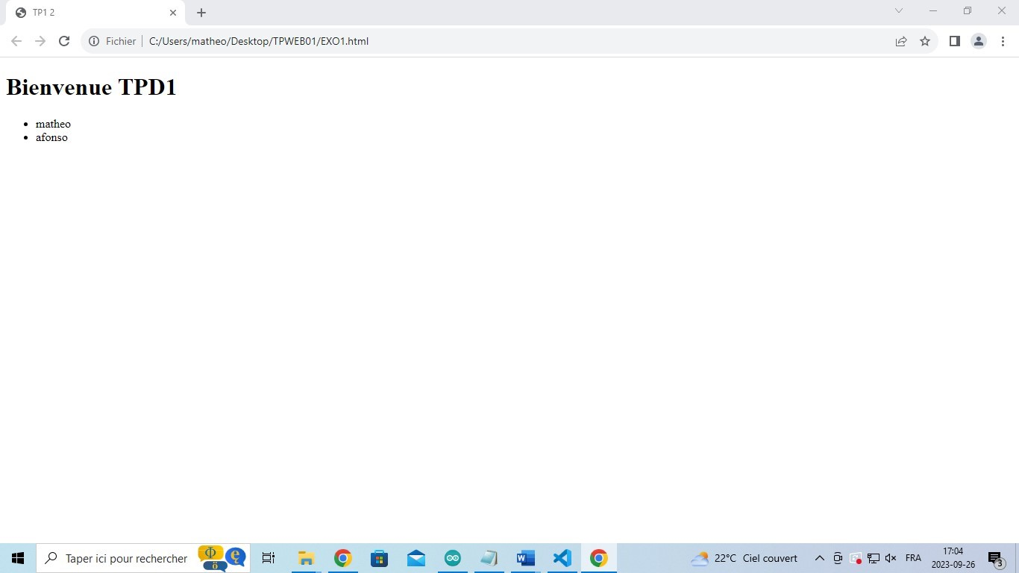

Balise span

<!DOCTYPE html>

<html>

<head>

    <meta charset='utf-8'>

    <title>TP1 2</title>

</head>

<body>

    <p> <span style="color: blue;">TP01</span></p>

</body>

</html>

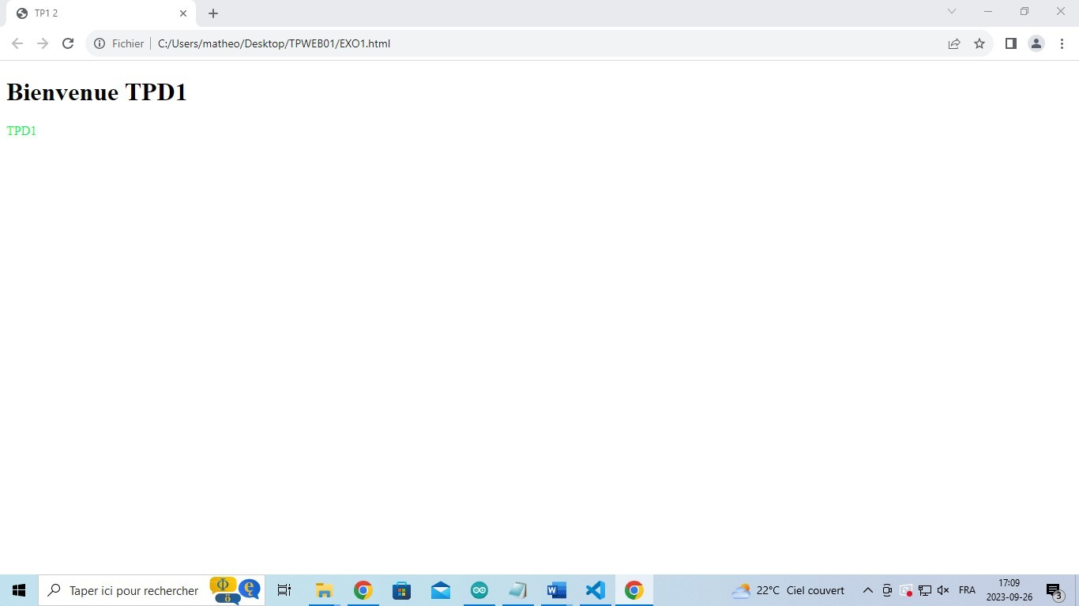

Balise form

<!DOCTYPE html>

<html>

<head>

    <meta charset='utf-8'>

    <title>TP1 2</title>

</head>

<body>

    <form>

      <input>

    </form>

</body>

</html>

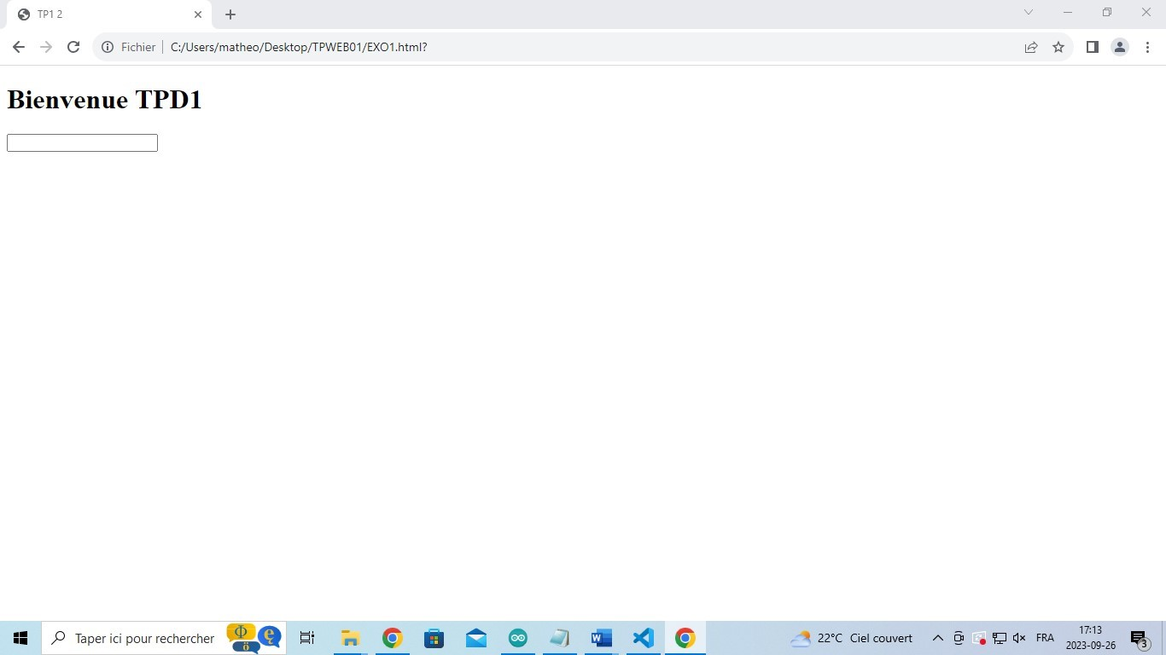

Balise textarea

<!DOCTYPE html>

<html>

<head>

    <meta charset='utf-8'>

    <title>TP1 2</title>

</head>

<body>

    <textarea>matheo afonso</textarea>

</body>

</html>

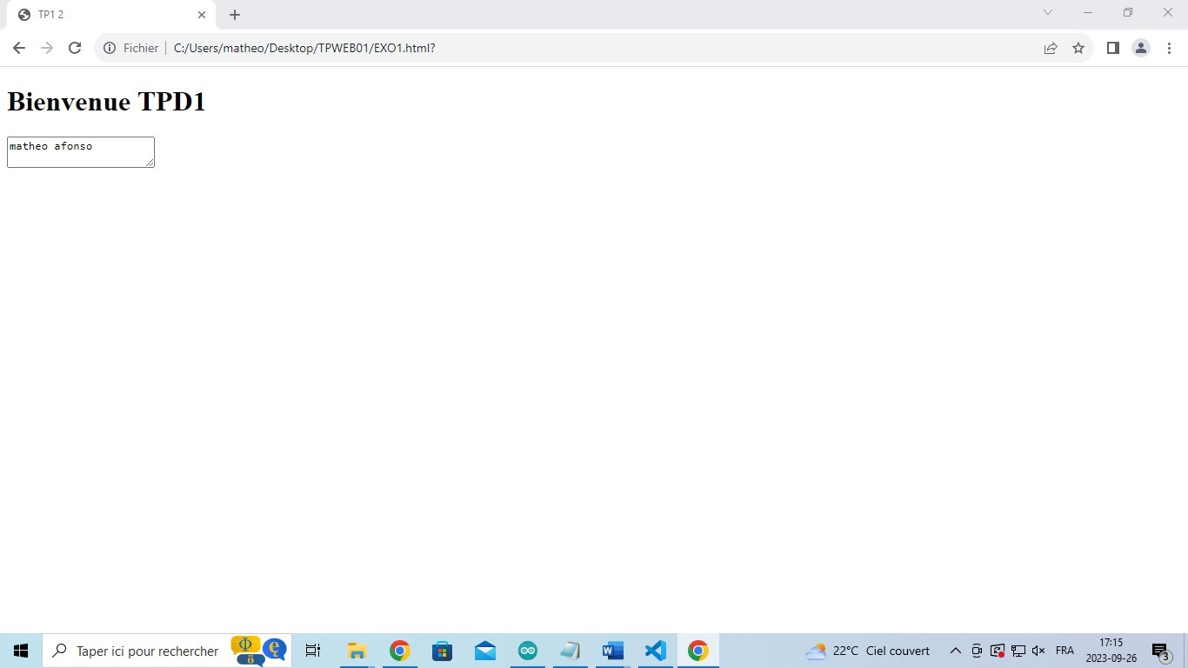

Balise button

<!DOCTYPE html>

<html>

<head>

    <meta charset='utf-8'>

    <title>TP1 2</title>

</head>

<body>

    <form>

      <button>matheo</button>

    </form>

</body>

</html>

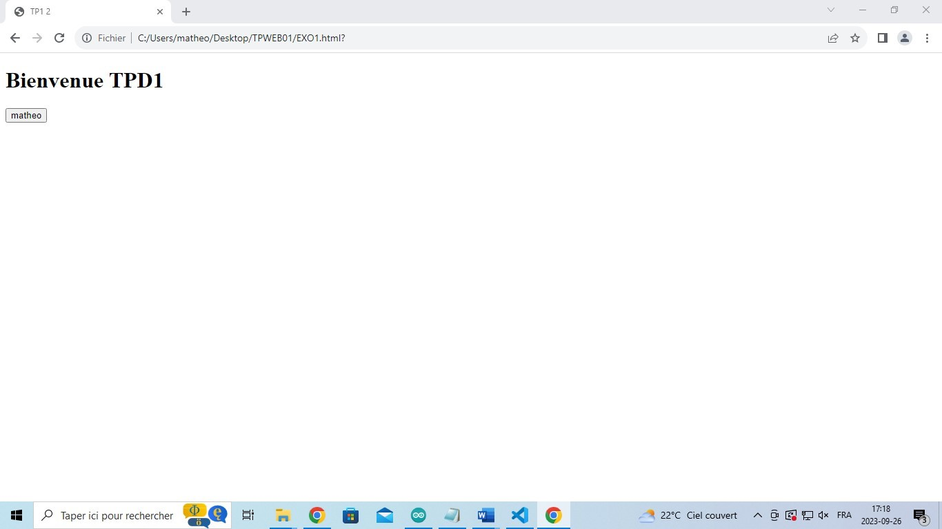

Balise hr

<!DOCTYPE html>

<html>

<head>

    <meta charset='utf-8'>

    <title>TP1 2</title>

</head>

<body>

    <hr>matheo afonso

</body>

</html>

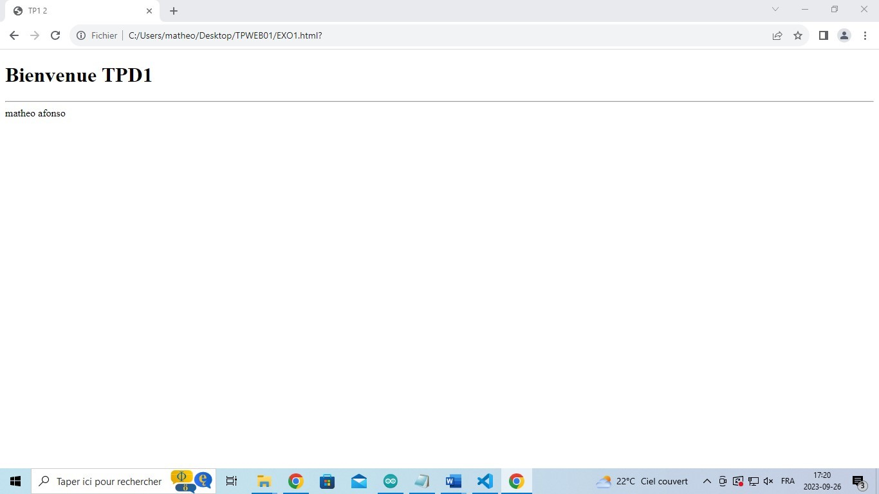

Balise br

<!DOCTYPE html>

<html>

<head>

    <meta charset='utf-8'>

    <title>TP1 2</title>

</head>

<body>

    <br>matheo afonso

</body>

</html>

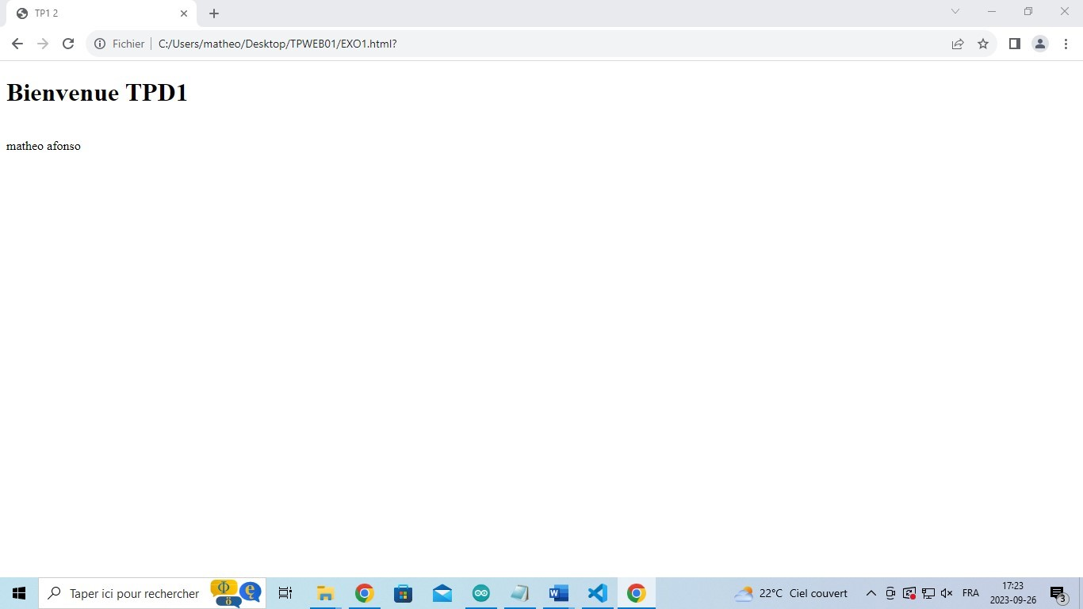

Balise blockquote

<!DOCTYPE html>

<html>

<head>

    <meta charset='utf-8'>

    <title>TP1 2</title>

</head>

<body>

    <blockquote>

      <cite>Je suis Cyberpunk</cite>

    </blockquote>

</body>

</html>

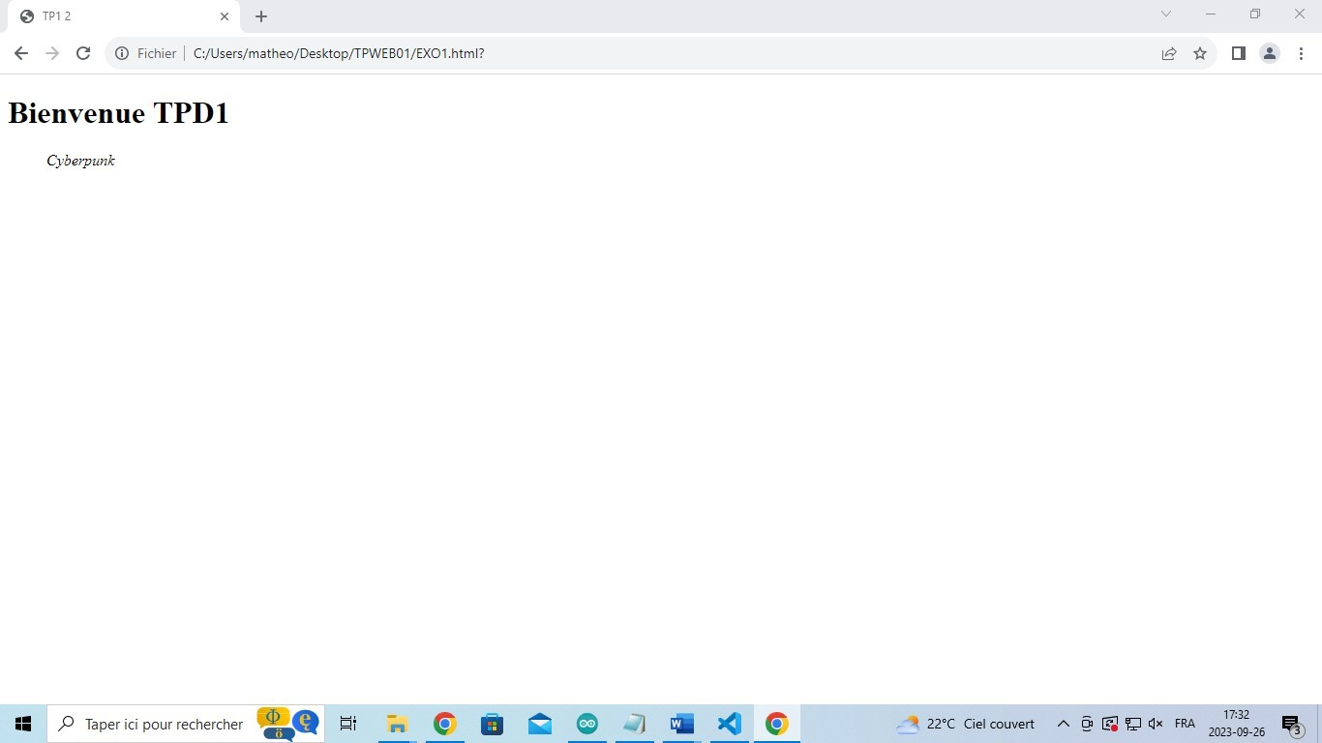

Balise em

<!DOCTYPE html>

<html>

<head>

    <meta charset='utf-8'>

    <title>TP1 2</title>

</head>

<body>

    <!-- test de balise ici -->

    <h1>Bienvenue TPD1</h1>

    <em>matheo afonso</em>

</body>

</html>

